Marmoset V1/V2 stimulation experiments
Oct 28, 2026 · @Someone

Questions
Two questions drive the experiments: whether the sequential benefit reaches V2, and how electrical activity compares with visual activity.
Question | Experiments that feed it | Hypothesis
Q1: does the sequential benefit (sequential > simultaneous stimulation of two electrodes, as in the rat) transmit from V1 to V2? | Single-pulse experiments, no visual stimulus | Sequential stimulation of two V1 electrodes evokes a larger V2 response than simultaneous stimulation at the same total charge, as in the rat.
Q2: how do electrical and visual responses differ, which stimulation parameters change the difference, and does sequential or shifted stimulation reduce it? | Train experiments (with visual trials), layer order, visual type | Electrical responses start earlier, rise and fall faster, and are more consistent from trial to trial than visual.

Q1 experiments
Experiment | One file = | Time | Hypothesis
Single pulse: amplitude | one amplitude (25, 50, 75 or 90 µA) | ~6 min | The benefit gets larger with higher current.
Single pulse: ISI | one ISI between the two electrodes (3 to 15 ms) | ~6 min | The benefit gets a peak around mid ISI
Single pulse: distance | one partner electrode (one distance) | ~6 min | The benefit increase then decrease as the electrodes move apart.
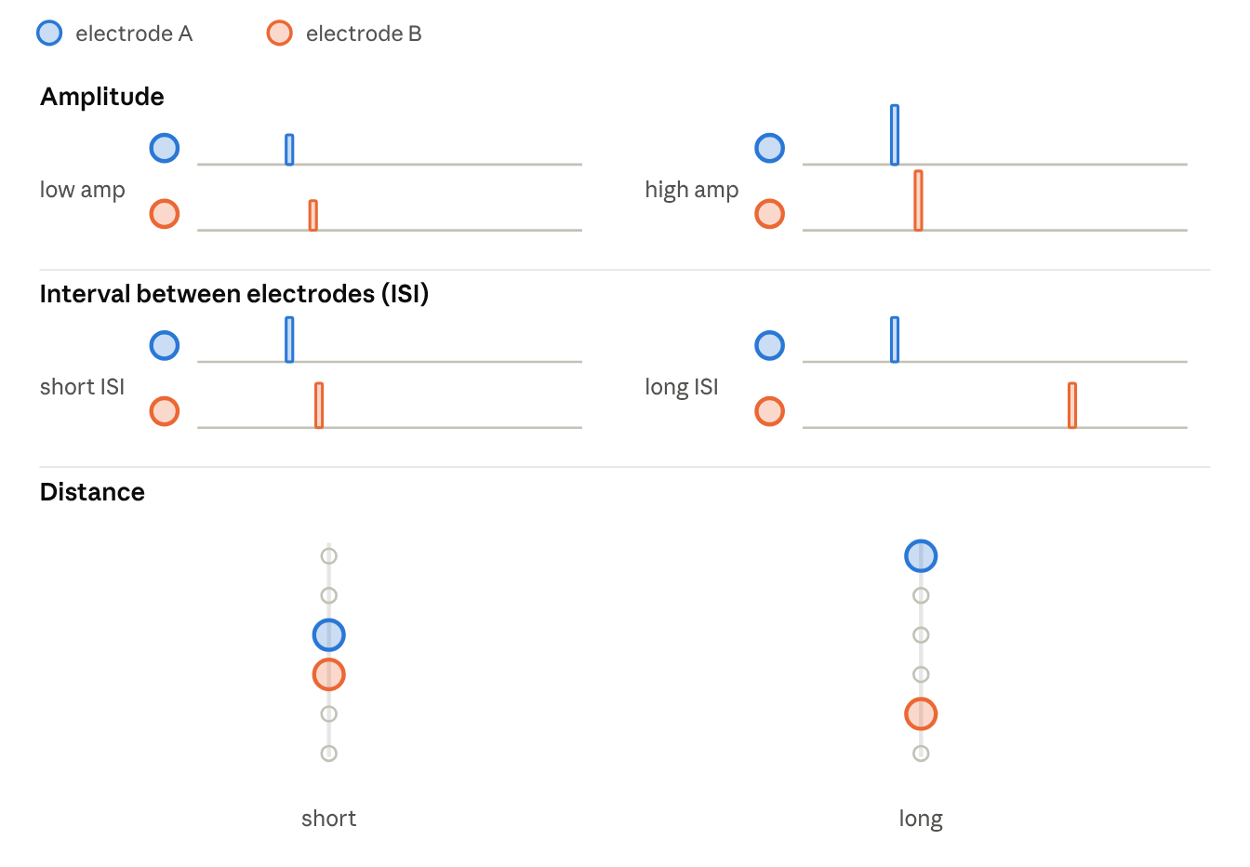
single-pulse experiments · amplitude, ISI, distance

Q2 experiments
Experiment | One file = | Time | Hypothesis
Train: amplitude | one amplitude | ~26 min | A higher amplitude evokes more spikes with a shorter latency and longer post-stimulus suppression. The higher amplitude moves the response further from the visual one, and the effect of sequential stimulation is the same at both amplitudes.
Train: ISI | one ISI (5 ms interleaved, 50 ms one-then-the-other) | ~26 min | An interleaved ISI (5 ms) gives one brief, merged burst with a higher peak rate. A one-then-the-other ISI (50 ms) gives two bursts in sequence, and the response is longer and flatter
Train: distance | one partner electrode (one distance) | ~26 min | Differences between patterns increase and then decrease with distance.
Train: electrode number | 1, 2 or 3 electrodes, same total charge, outer span fixed | ~11 / ~18 / ~22 min | Spreading the same charge over more sites lowers the current at each site, so the response is weaker than one chn only, but but make the response longer.
Train: frequency | one frequency (50 to 400 Hz), ISI = half a period | ~26 min | Frequency changes how fast the response builds up and how much spike counts vary from trial to trial.
Layer order | L4 then L2/3, or L2/3 then L4 (5 ms ISI) | ~26 min | L4 then L2/3 differs from random stim. one order sits nearer the visual response.
Visual type | spot and Gabor variants at 3 contrasts, no electrical stimulation | ~14 min | A stimulus that drives ON, OFF and several orientations (the Gabor) may give spike statistics nearer the electrical response than a single-polarity spot.
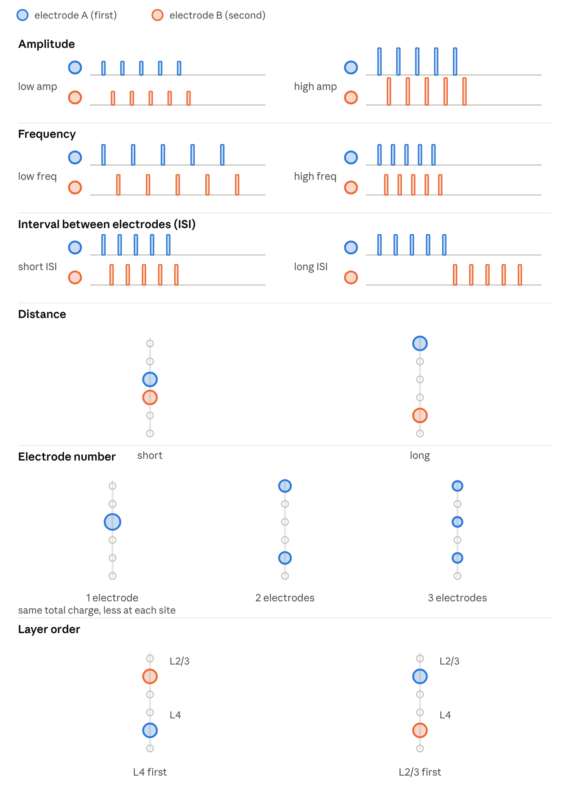
train experiments · amplitude, frequency, ISI, distance, electrode number, layer order

Settings behind the times
Setting | Single pulse | Train
Pulses per electrode | 1 | 5, at 100 Hz
Amplitude | 75 µA, or the varied value | 75 µA, or the varied value
Interval between electrodes | 5 ms, or the varied value | 5 ms (half a period), or the varied value
Order | A then B and B then A | A then B and B then A
Visual trials | none | spot, bright and dark, at 3 contrasts (0.12, 0.5, 1), plus a blank
Repeats per condition | 20 | 20
Trial length | 400 ms | 500 ms

Trial timelines
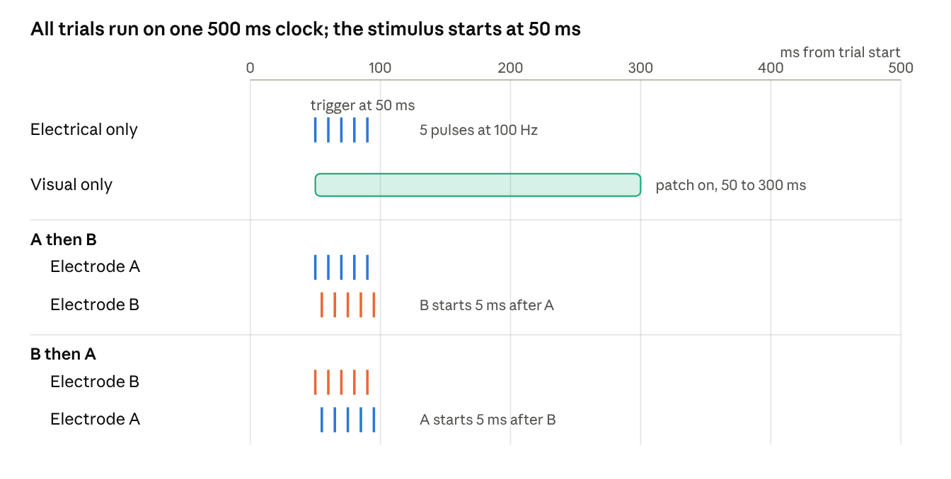
trial timelines · electrical, visual, A then B, B then A
Electrical and visual trials start at 50 ms; in a paired trial the second electrode starts 5 ms after the first, in either order.

Measures
Question | Measure
Q1 | Evoked spike count in V2 (and V1), sequential vs simultaneous at the same total charge
Q2 | Fano factor (trial-to-trial variability of spike count), spike count distribution, PSTH shape (onset, rise, fall)

Appendix: session time by pulses and visual setting
One train file at one value of the varied setting, 20 reps, both orders. With 1 pulse the electrical conditions are the single-pulse design (sim, A then B, B then A, A only, B only).
Pulses per electrode | Electrical conditions | 5 contrasts + blank | 3 contrasts + blank | No visual arm
1 | 5 | 16 conditions, ~14 min | 12, ~11 min | 6, ~6 min
2 | 10 | 21, ~18 min | 17, ~15 min | 11, ~10 min
3 | 15 | 26, ~21 min | 22, ~18 min | 16, ~14 min
4 | 20 | 31, ~25 min | 27, ~22 min | 21, ~18 min
5 | 25 | 36, ~29 min | 32, ~26 min | 26, ~21 min
Each contrast adds 2 conditions (bright and dark), about 1.5 min per file. Times use 2.3 s per trial (1.5 s inter-trial gap) and 1.5 min for start and end; they do not include any change to the gap.

